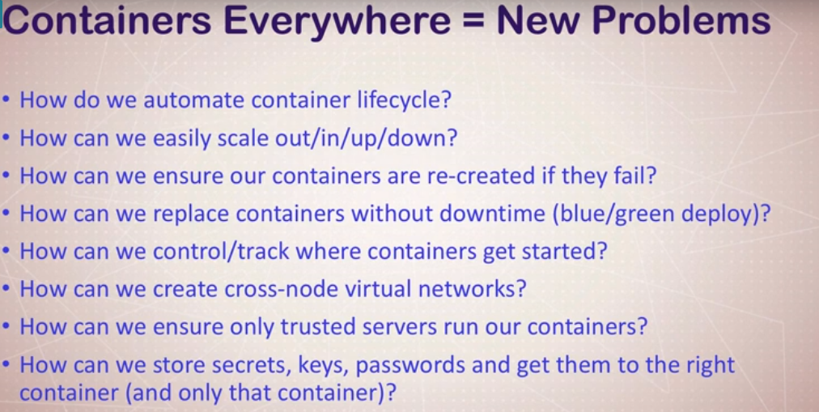

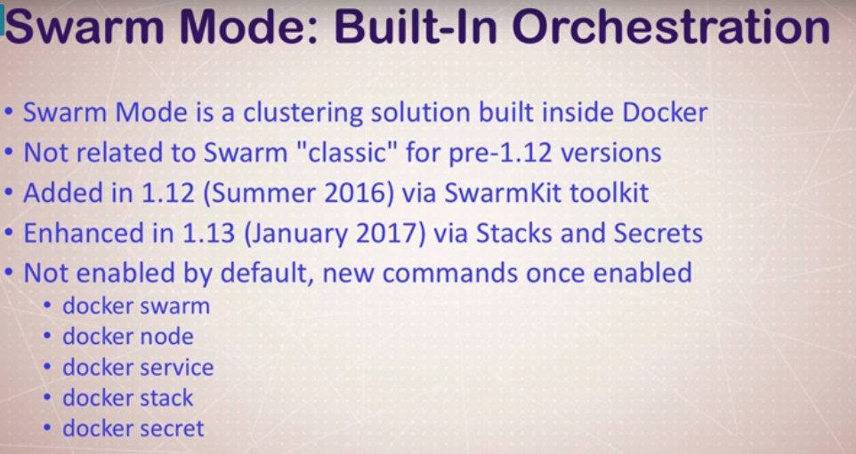

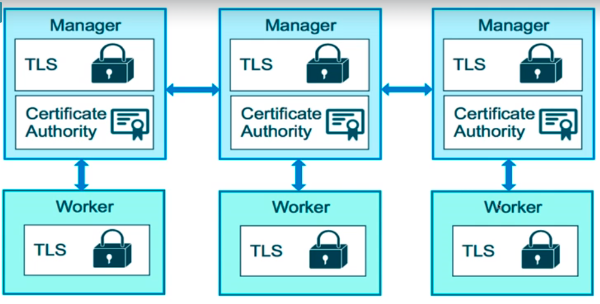

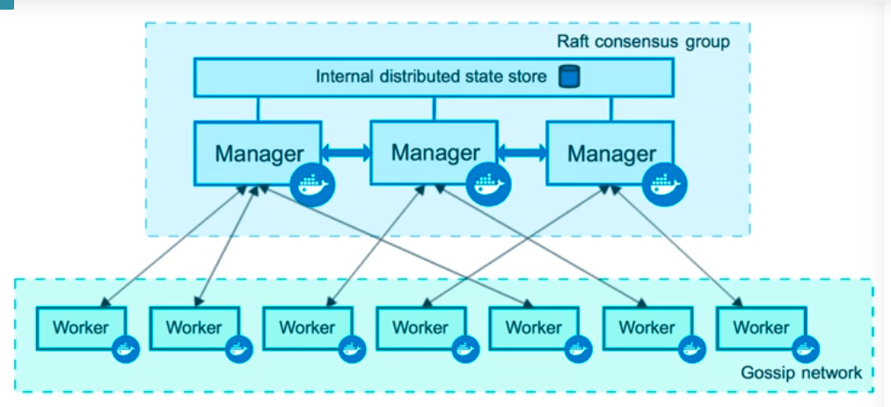

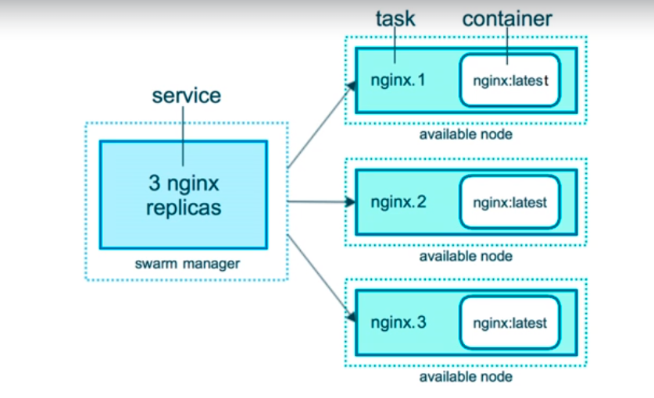

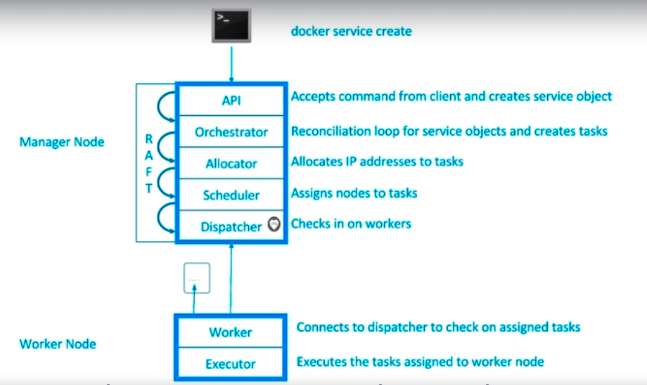

**Swarm services** -

By default, swarm will be disabled on docker.

We can check this by running this command – docker info

To enable swarm – docker swarm init

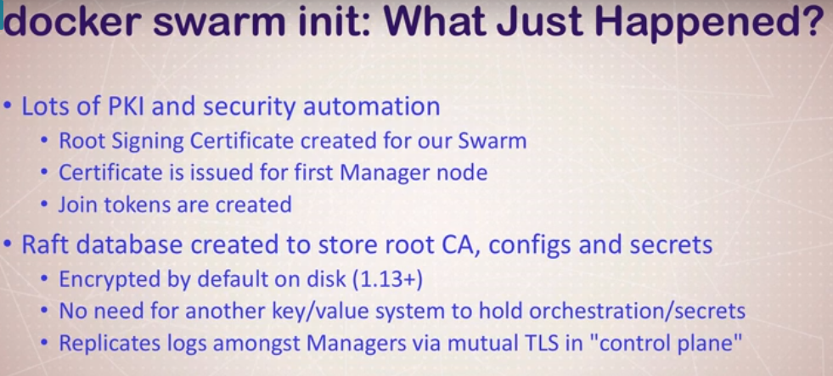

docker node ls



docker service create alpine ping 8.8.8.8

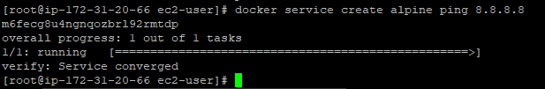

docker service ls



docker service ps <name_service> - give the details of the task



docker service update <name_or_id_of_service> --replicas 3

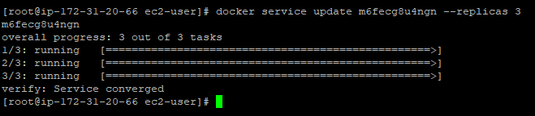





docker container rm -f <name>.1.<id>



docker service rm <name_service>



docker service ls



docker container ls



docker swarm –help

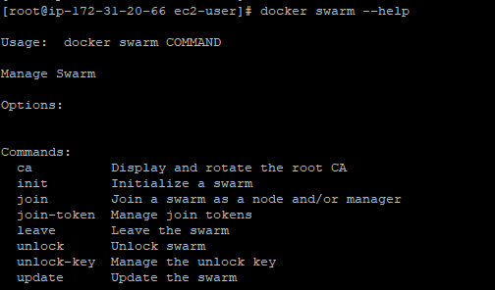

Docker node –help

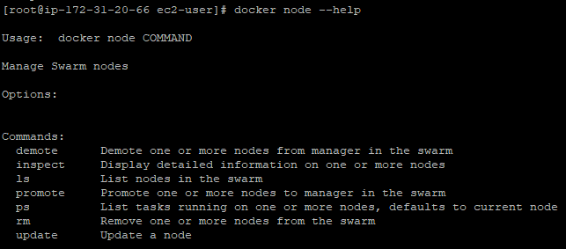

docker service –help

